A Project Report on

**University Allocation**

Submitted as a mini-project

By

**Ankitha P**

Hall Ticket No. 1601157337122

And

**Lehya Reddy K**

Hall Ticket No. 160115733129

Under the guidance of

**G. Vivek**

Asst. Professor

Department of CSE,

CBIT, Hyderabad

**Department of Computer Science and Engineering**

**Chaitanya Bharathi Institute of Technology**

**Gandipet, Hyderabad – 500075**

**CERTIFICATE**

This is to certify that the project titled “University Allocation” is a bona-fide work carried out by Ankitha P and Lehya Reddy K, in completion of a mini-project under our guidance and supervision.

The results embodied in this report have not been submitted to any other university or institute for the award of any degree or diploma.

Internal Guide Head of Department

**G. Vivek**  **Dr. Y. Rama Devi**

Asst. Professor Professor and Head of

Department of CSE Department of CSE

CBIT, Hyderabad CBIT, Hyderabad

**ACKNOWLEDGEMENTS**

We would like to express our heartfelt gratitude to Mr. G. Vivek, our project guide, for his invaluable guidance and constant support, along with his capable instruction and persistent encouragement.

We are grateful to our Head of Department, Dr. Y. Rama Devi, for her steady support and the provision of every resource required for the completion of this project.

We would like to take this opportunity to thank our Principal, Dr. Chennakesava Rao, as well as the management of the institute, for having designed an excellent learning atmosphere.

Our thanks are due to all members of the staff and our lab assistants for providing us with the help required to carry out the groundwork of this project.

**ABSTRACT**

This project seeks to reform the mainstream tiresome college allocation procedures post results announcement of competitive exams such as EAMCET, JEE etc. The aim of this project is to establish a smooth interface between a college seeking student and the colleges.

This project allows users which are of two types- Student and Admin, to register and login through the interface provided in a simple C++ code. This project uses basic concepts of files and database systems to be implemented as required.

After the registration and login are implemented successfully the student user can easily enter the options of colleges he prefers from the list of colleges already provided. The admin can control the allocation procedure and can update, modify the information present and can start the allocation procedure after which each student user can see the respective college allocated to him/her.

**LIST OF SCREENS**

Figure C: Classes and function abstract

Figure 1: Home Screen

Figure 2: Student Login Screen

Figure 3: Student Registration Screen

Figure 4: Student Home Screen

Figure 5: Student Options Entry screen

Figure 5.1: List of colleges

Figure 5.2: List of options

Figure 6: Student Information Screen

Figure 7: Admin Login Screen

Figure 8: Admin Home Screen

Figure 9: Admin Information Screen

Figure 10: Admin - Student Display Screen

**CONTENTS**

Abstract

List of Screens

1. Introduction
   1. Motivation
   2. Problem Definition
   3. Objective of the Project
   4. Limitations of the Project
2. Literature Survey
   1. Introduction
   2. Existing system
   3. Problems in the existing system
   4. Proposed System
3. Analysis
   1. Introduction
   2. Software and Hardware Requirement Specification
   3. Conclusion
4. Implementation and Results
   1. Introduction
   2. Explanation of Key Functions
   3. Method of Implementation
      1. Classes
      2. Output Screens
      3. Result Analysis
5. Testing and Validation
   1. Introduction
   2. Design of test cases and scenarios
   3. Validation
6. Conclusion

**CHAPTER 1**

**INTRODUCTION**

**1.1. Motivation**

The only motivation needed run this project is the difficulties faced by the students in their process to find their college of their dreams. A simple and economicable procedure or a process is required in this era of digitalization and competition. This in the same manner decreases the logistic efforts needed to be made in their allocation procedures.

**1.2. Problem Definition**

The problem with the current allocation procedure is the requirement of a material judge of a student’s ranks. The selection procedures have been way to tedious in the past consideration the psychological factors of dealing with the various steps of selection which might hinder a skilled student for achieving what he/her had wished for, deserved to get.

**1.3. Objective of the Project**

The objective of the project as stated above is to eliminate the logistics of the allocation procedures and to decide in which college the student prefers or chooses. This project will ensure comfortable process of achieving the same.

**1.4. Limitations of the Project**

The results of this particular have been confined to one programming language. The scope of the test and the interface of the project can be much more sophisticated at the back and as simple in the front. There are certain functionalities of the project that can be improved and the project will achieve the same.

**LIST OF FUNCTIONS**

This code aims to allocate colleges to the students after getting their details such as name, date of birth, hall ticket number, rank achieved by them in the competitive exam, list of options of colleges they would want to go. There is a list of colleges made available by the admin. The admin enjoys the right to add new colleges change/modify the access information available to student users. The admin controls the allocation procedure.

The following is the list of functions used in the code

1. St_register() : Takes the details of the student
2. Clg_list() : Displays the list of colleges the admin has made available for the student user
3. Options () : Allows the student user to enter 5 options from the list of colleges
4. St_show :Displays the student rank and the 5 options he chose.
5. Student() :Calls the student function
6. Admin() :Calls the admin function

Yet there are still some functionalities and details that are to be added in our code

**OUTPUT SCREENS** 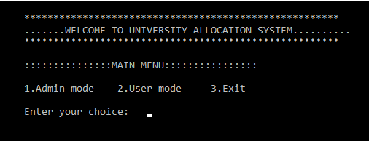

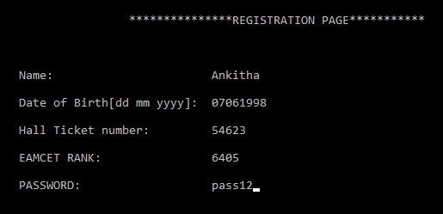

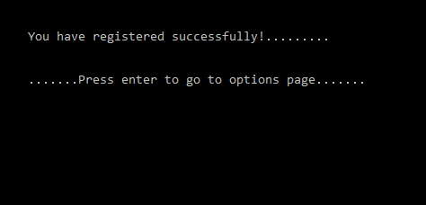

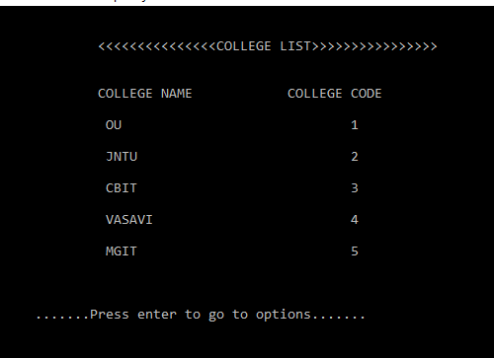

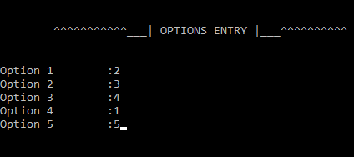

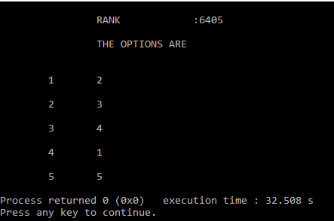

**CODE FOR THE ALLOCATION**

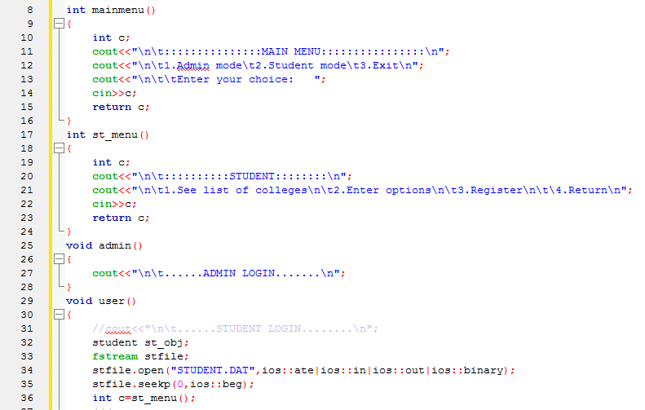

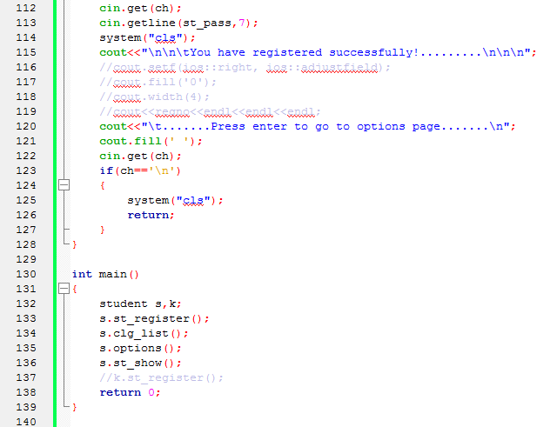

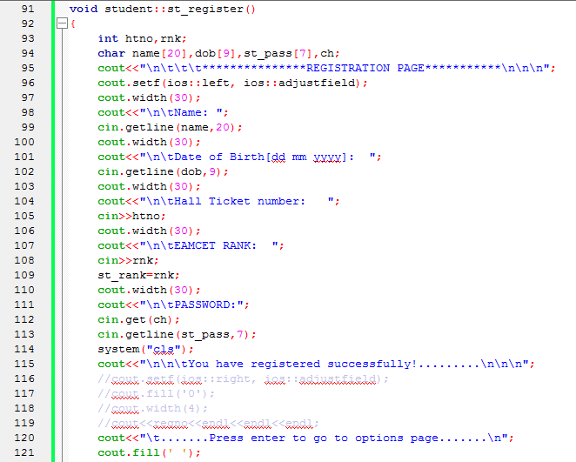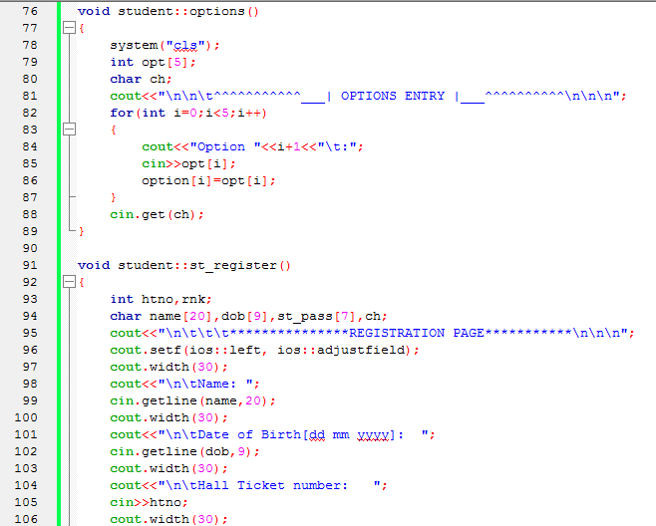

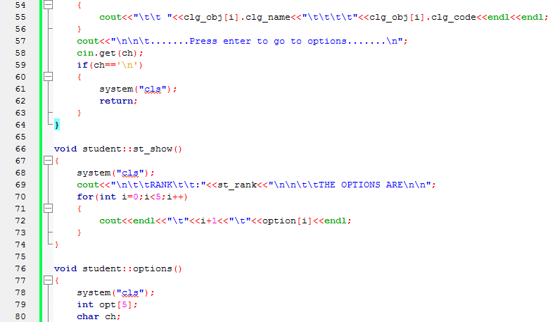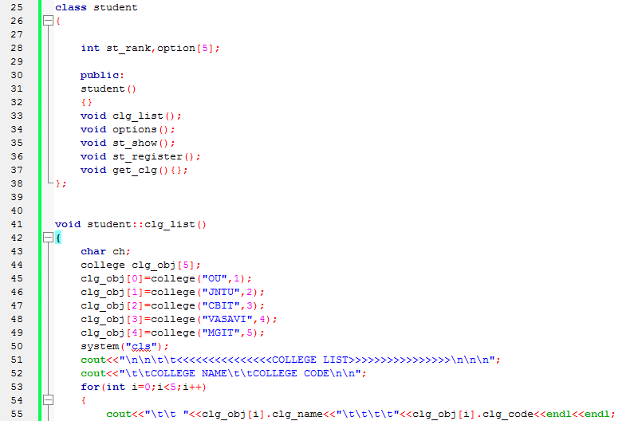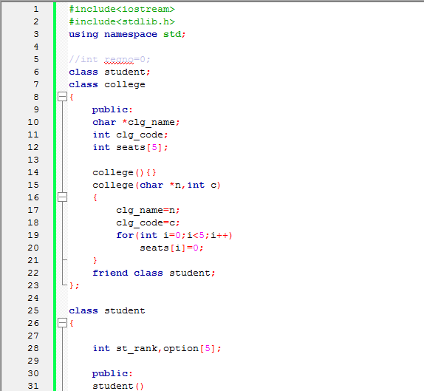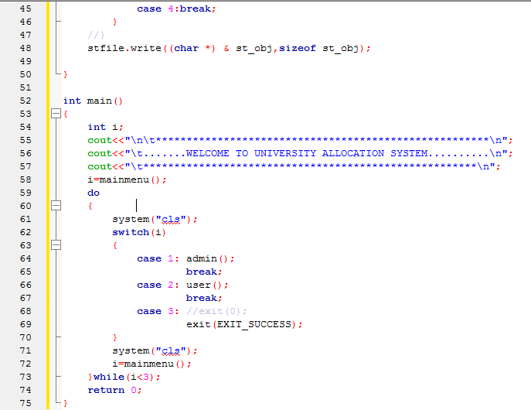

**CHAPTER 5**

**CONCLUSION**

This project achieves its purpose in many aspects of the problem statement. The smooth interface between the student and the allocation procedure is necessary to go about the process of umiversity allocation. This significantly reduces the tiresome task of individual allocation procedures by individual colleges and universities and this code makes it generic or a better and smooth selection procedure. This projects holds many basic concepts to accomplish something different which can be used in many fields later on.

This same project can be improved in many aspects at a micro level to improve the interface and quality of the test and the idea which with a proper time spent can be achieved for example aspects of time and the sections of questions can be made selective and which the same can be achieved by further usage of other programming languages. The project is expected to achieve the same in the future levels of enhancements.